ECE 5470 Computer Vision Lab4 report

Image filtering

Weiran Wang

NetID: ww463

1. Two channels refer to real channel and imaginary channel
2. We used vfix command to change the data base type to float, then subtract the average pixel value of the whole image from every pixel, in this case, the average pixel value is 110.366. Then vfft command is used to compute the FFT of the image. Finally, we use vexfft command to take log before scaling the magnitude
3. The value of bf parameter was acquired by calculating the negative of the average pixel value of the image
4. The first line generates a image whose x dimension and y dimension are both 128. A circle whose radius is 32 is created by specifying c parameter. The hi parameter specifies the high pixel value which is used for the generated patterns. After the image is generated, use vfix to change the data base type to float.

f1 is a one channel image, after using f1, it becomes a dual channel image. This is for the future use of the command vop to multiply with ted.fft.

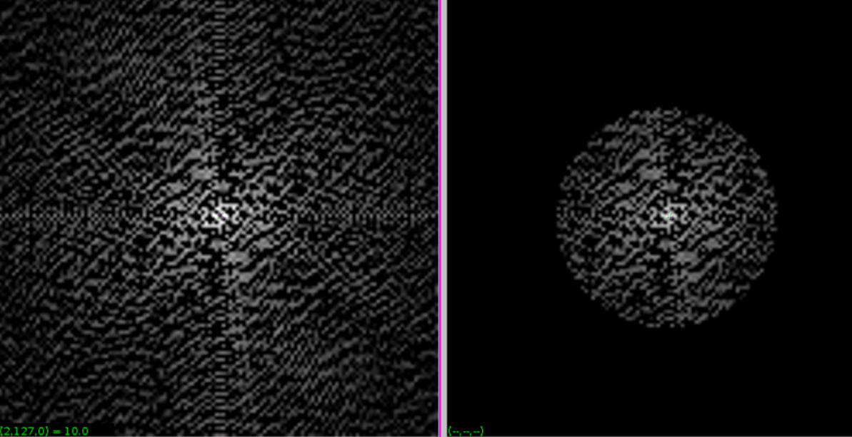

Fig1 filtered ted image(magnitude)

*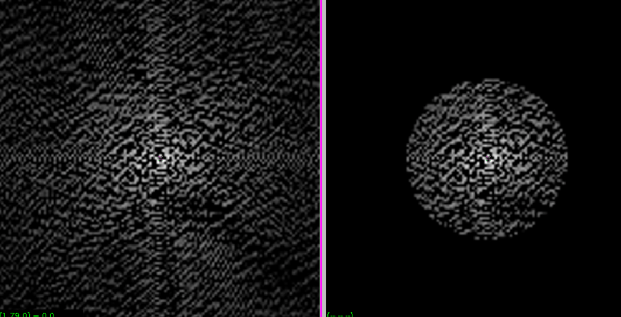*

Fig2. Filtered ted image(phase)

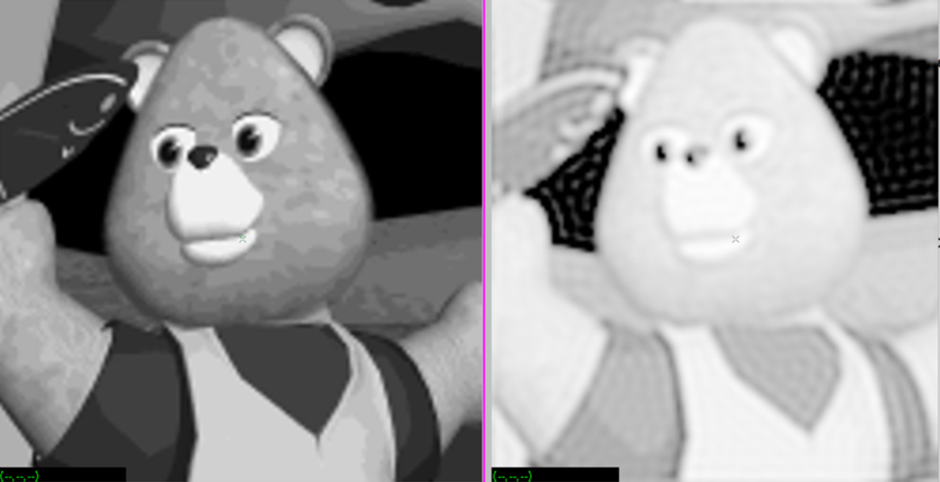

Fig3. Result of inverse FFT

After filtering, the image is brighter, but it’s not as clear as before. Some details of the image has been filtered out

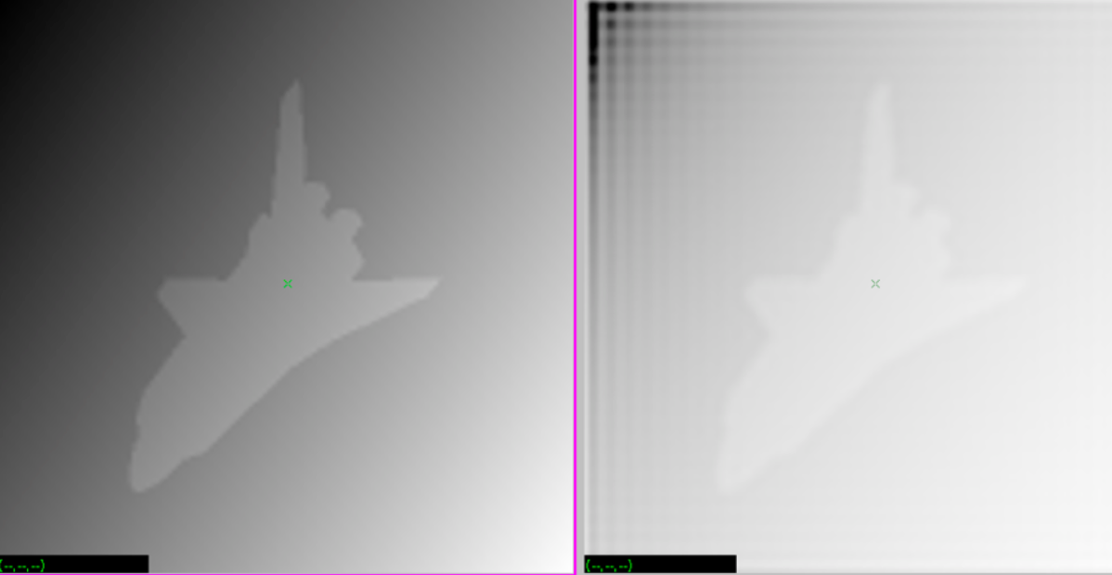

Fig4. Result of inverse FFT on sshtl

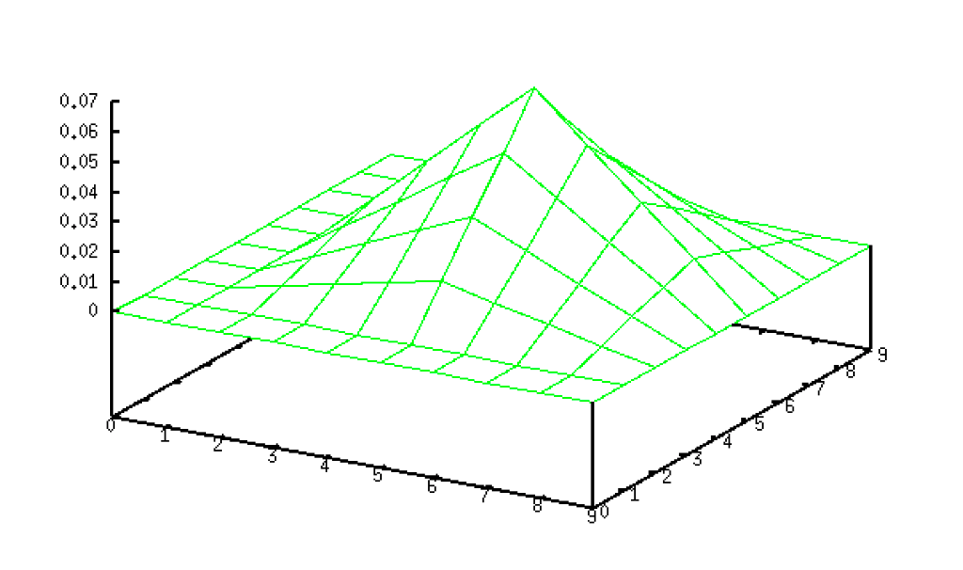

Fig5. Spatial filter

First, it generates a 10\*10 image with a 2\*2 rectangle in the middle. Its highest pixel value is 1, and then this image convolves with itself to get the sf2. Finally, we multiply each pixel value by 0.0039 using vpix to get the sfi1.

We decide the parameter tf value according to the mean pixel value of the image.

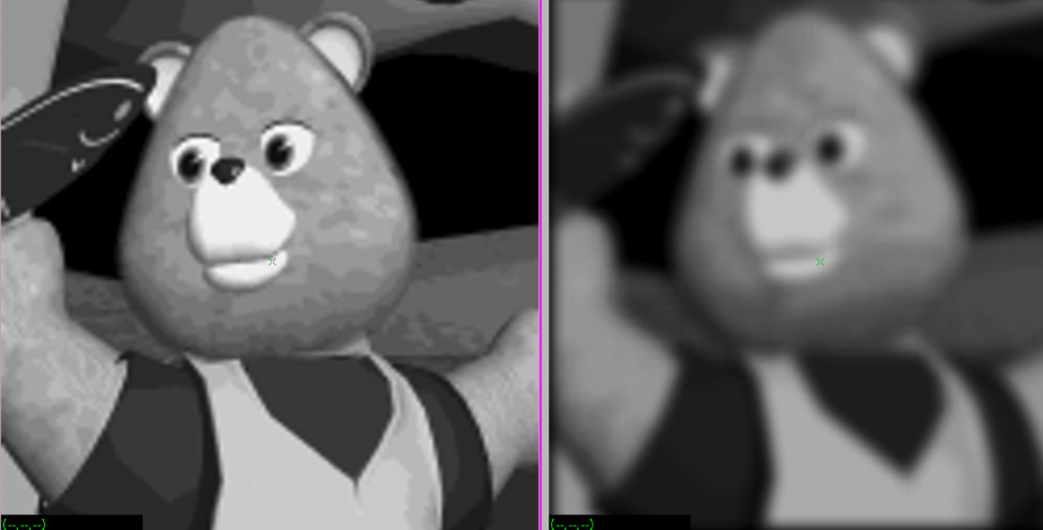

Fig6. result of filtering

After filtering, the image is not as clear as before. The filter removed the noise but also wiped out some details of the image. The image is more blurry than before.

